1.1 About CRDB BANK PLC (Partner)
CRDB Bank Public Limited Company (PLC) is a leading Bank in Tanzania providing retail banking, corporate banking, MSMEs and Women-MSMEs services in Tanzania as well as Burundi and DRC Congo. It is the largest bank in Tanzania by assets and profitability. CRDB Bank Public Limited Company (CRDB) was registered June 28, 1996. The bank It has been listed on the Dar es Salaam Stock Exchange (DSE) since June 17, 2009.
Currently CRDB Bank offers a compressive range of Corporate and Retail services through a network of over 253 branches. In January 2023, the Bank started implementing the Group’s Business Strategy for 2023-2027. The key strategic goal is to be undisputed leader in the market by 2023. Bank’s long-term purpose is to Improve livelihoods and deliver sustainable Impact. Current strategy focuses on 4 key areas women, youth, agriculture and MSMEs.

1.2 About African Guarantee Fund
AGF main objective is to provide financial support and assistance to African SMEs in the most decisive phases of their cycle-Start-up and Growth stages, by sharing the risks involved with Partner Financial Institutions (PFIs)-banks and equity capital investors.

2 Background of the Assignment
This Training aims at enabling employees to understand key principles of effective portfolio management and use the knowledge to obtain desired portfolio quality. Training coverage includes loan onboarding, monitoring, managing problem loans, effective loan collection, loan classification, loan provisioning, working recovery strategies, loan structuring etc. Training will further provide CRDB Bank employees knowledge on calculating expected credit loss monitoring under IFRS 9 and other regulatory provisions; CRDB targets to train at least 400 Frontline staff.

3 Training Requirement
The bank seeks to provide comprehensive training to its staff members involved in business loan portfolio management. The primary objectives of this training are to enhance the participants understanding of business loan portfolio dynamics, risk assessment, mitigation strategies, and best practices in managing a diverse range of business loans.
3.1 Scope of Work:
The training program will cover the following key areas:
- Customer selection and onboarding
- Principles of Business Loan Portfolio Management
- Risk Assessment and Mitigation Strategies
- Loan portfolio classification and provisioning
- Loan Structuring and Documentation
- Financial Analysis of Borrowers
- Monitoring and Early Warning Systems
- Non-Performing Loan Management
- Regulatory and Compliance Considerations
- Technology and Tools for Portfolio Management
- Specific skills in managing women-MSME portfolio and green-MSME portfolio

3.2 Target Beneficiaries
Portfolio Management staff, Credit Underwriting staff, Managers & SM Business Banking, Relationship Officer, Relationship Managers, Branch Managers, Monitoring team at Head office, Zonal Business Managers & Zonal Business Quality, Branch Quality Assurance and SAMU staff.
3.3 Specific Training Objectives:
The training program aims to:
- Increase employees understand of key principles of effective portfolio management
- Enhance understanding and ability to Manage problem loans,.
- Improve ability to develop workable recovery strategies,
- Improve credit structuring.
- Increase ability to calculating expected credit loss and monitoring under IFRS 9,
- Gain skills of easy risk identification and develop ringfenced mitigation.
- Special skills-focus on women-financing for the above topics
- Special skills-focus on green financing for all the above topics

4 Brief profile and titles of majority targeted staff/beneficiaries:
Total 400 staff with background experience in lending, sales, and credit management are expected to be trained.

Brief duties of staffs to be trained are:
- Relationship Officers - These are Loan Officers originating MSME loans at branches from branch network countrywide. They oversee loans of up to TZS. 500 million (USD199,579.81). Also responsible for customer recruitment and portfolio quality at respective branches etc.
- Relationship Managers – Originate MSME and manage loans from zonal level overseeing loans of up to TZS. 5 Billion(USD 2.5 Million).. Also responsible for customer recruitment and portfolio quality at zone etc.
- Manager Business Development- These are officers responsible business development at branch level. Also responsible for customer recruitment and portfolio quality at branch level.
- Credit Analysts – Analysing and making recommendations on credit applications and appraisal from Relationship Officers and Relationship Managers.
- Senior Specialists Portfolio Management – Responsible for MSME portfolio quality management of stakeholders on MSME for maintaining a healthy loan book.

5 Training Methodology/Delivery Options
A key feature of Commercial MSME Lending Fundamentals is the flexibility with which it can be administered. The consultant will provide best and cost-effective training modality and class size that will allow best learning space to staff. The course is appropriate for existing and new staff in targeted departments. Due to large number of staff to be trained, this course will be undertaken in batches by considering maximum class capacity. A Mix of instructional methods including presentations, group discussions, role plays, case studies, etc.
Resources required for the training include training manuals, audiovisual equipment, interactive and participatory encouraging active. It is imperative that all proposals be accompanied by Daily Course Program together with specific Case Study Titles and Group Work topics within the training lectures.

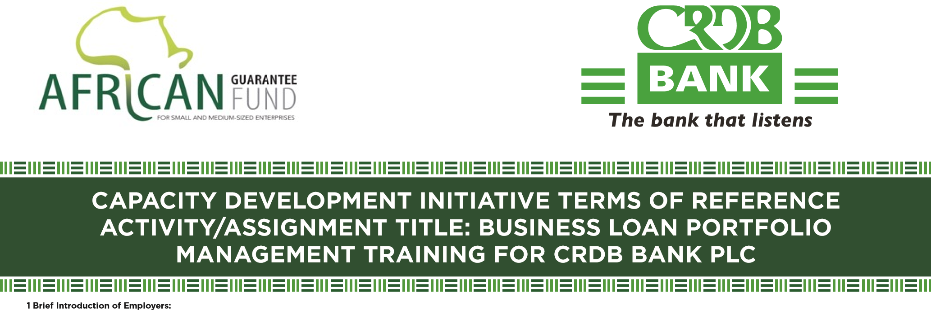
6 Expectations from the Consultant
Commercial MSME Lending Fundamentals is designed to provide key skills to Branch Staff, Relationship Managers/Officers, Business Development Managers, and Credit Analysts who deal with the MSME segment of the business within the Bank. It is expected that the Consultant will undertake the following tasks as part of the proposed Methodology:
- Undertake a Training Needs Assessment (TNA) of the staff involved in SME lending business with a view to determining/firming-up the actual skills-gap. The TNA Report must cover skills gap in as far as women-MSMEs and green-MSME lending business is concerned,
- A Training programme will then be developed including identifying country for staff to visit and be exposed to best practice and also embedded as part of the orientation process for new staff joining the MSME banking business,
- The Training programme will then be undertaken for the existing staff; and
- Produce periodical reports and final project reports to the Bank.
- To monitor and evaluate trained staff work quality after completion of training as per expected output above.

7 Expected Deliverables
The following are the expected Deliverables or Outputs in hard and soft copies and the indicative timelines.
- Training Needs Assessment Report discussed and approved by CRDB and AGF
- Training materials in soft
- Training Report in hard and soft
- Pre and post Training survey Report
Timelines for Undertaking the Training project is from November 2025. The specific timeline as stipulated in the work plan, below are timelines for broad output:
# | Output | Expected Indicative Timeline
1 | Number of staff trained 400 | November 2025 to October 2026
2 | Project completion report | October 2026

8 Expected Impact
Below are some of the impacts the Bank would like to see after the Training include:
- Demonstrate a clear understanding of balancing profitability with risk exposure in loan product offerings.
- Apply Portfolio Management principles to effectively manage MSME portifolio with diverse perspectives.
- Equip with tools to monitor loan repayment trends, arrears, and non-performing loans.
- Improves data-driven decision-making for restructuring and refinancing options.
- Guide on structuring a diversified loan book across industries, reducing concentration risks.
- Reinforces understanding of local and international lending regulations.
- Enhances risk management policies, ensuring compliance with financial authorities.
- Demonstrate ability to evaluate borrower risk profiles and loan performance.
- Improve strategies for minimizing default rates and ensuring healthy portfolio growth not limited to managing problem loans, effective loan collection, working recovery strategies.

9 Criteria/Qualification/Profile of the Consultant:
- A Certified Training Consultancy Firm(s) (Provide necessary legal registration document);
- Experience of not less than 5 yrs in Business Portfolio Management training in Banking Industry.
- Experience of not less than 5 yrs in in MSME portfolio management in Africa Banking Industry or similar market.
- Experience in Digital and Transactional Portfolio Management in Banking Industry Africa
or similar market.
- Experience in green-MSME and women-MSME lending.
- Curriculum Vitae & Academic Certificates of all staff that will be directly or indirectly involved this assignment.
- Report (s) showing performance of completion of similar work previously done with references.
- Minimum number of years of experience: 5 years on MSME segment.
- Minimum degree qualification of the Lead and Associate Consultants.
- Expected field experience areas as per training requirements on section 3 above.
- Other experience areas: Financial management, MIS, loan recovery, different working templates including reports, sales etc.
- Compliance with ESG/Sustainability
- Legal Requirements expected from Consultant/Consulting Firms:
Registration documentation per given jurisdiction and to be subjected to Due Diligence before contracting.
- Confidentiality
Confidentiality and data protection clause to be included in Consultancy Agreements.

12 Consultants Registration
Consultants need to register using the following link: https://www.surveymonkey.com/r/WY8F9FN (Ignore if you have registered before).

13 Implementation Timeline
It is expected that the Assignment/Activity will commence in November 2025 to October 2026 for a period of about 12 months.

14 Deadline for Submission of Terms of Proposal
The deadline for submission of the proposal is 20th August 2025, by 16:00 hours EAT.

15 Proposals should be emailed to:
Tenders will be advertised at CRDB website, LinkedIn and Newspapers. Tender documents to be submitted to tenders@crdbbank.co.tz Copy to procurement@africanguaranteefund.com. All proposals Technical and Financial should be submitted separately and encrypted.

The Managing Director
CRDB Headquarters,
Plot No.25 & 26 Ally Hassan Mwinyi Road &
Plot No.21 Barrack Obama Road
P.O. Box 268, 11101 Dar es Salaam, Tanzania
Tel: +255 (0) 22 211 7441 – 7
Fax: +255 (0) 22 211 6714
Email: info@crdbbank.co.tz
Website: http://www.crdbbank.co.tz

Contact Person AGF:
Group CD Director – Patrick Lumumba
Email: patrick.lumumba@africanguaranteefund.com

